Running head: Consulting Project

CS 3910: Assignment: Consulting Project

Mordred Cameron

Annabel Fuina

Alec Ankrum

University of Colorado Colorado Springs

In partial fulfillment of the requirements for CS3910 Instructor: Rhett Saunders

26 April 2024

# Introduction to Consulting Project

Using a set of provided business requirements, this assignment will set up the network and business logic applicable to the organization. The organization contains 3 different departments, the IT department, software, and sales. The IT department will have two Domain Controllers (DCs) that can be remotely accessed by administrators on an Active Directory that manages authentication and authorization. The remaining departments will have normal users with limited functionality as well as a local administrator responsible for the oversight of that department. The business requests a simple public facing website, a Linux server for the software development team, as well as a demo application that shows the team the benefits of embedded user rights and access.

# Assignment Results

## **Network Topology Diagram**

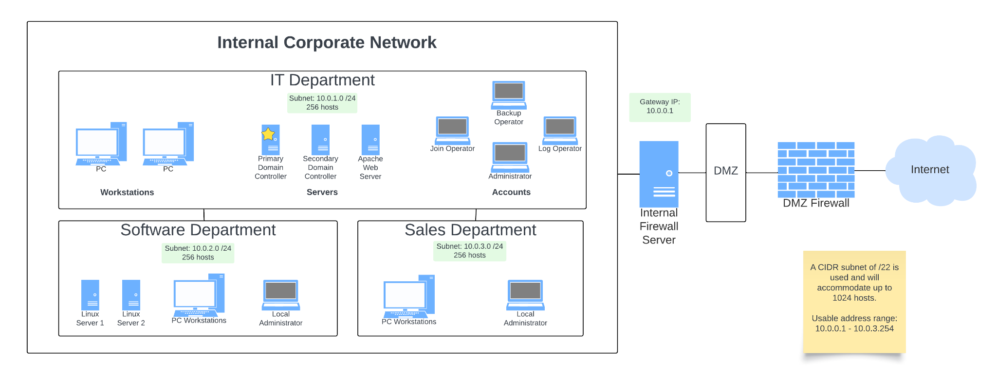

## 

## 

## **Business Logic Diagram**

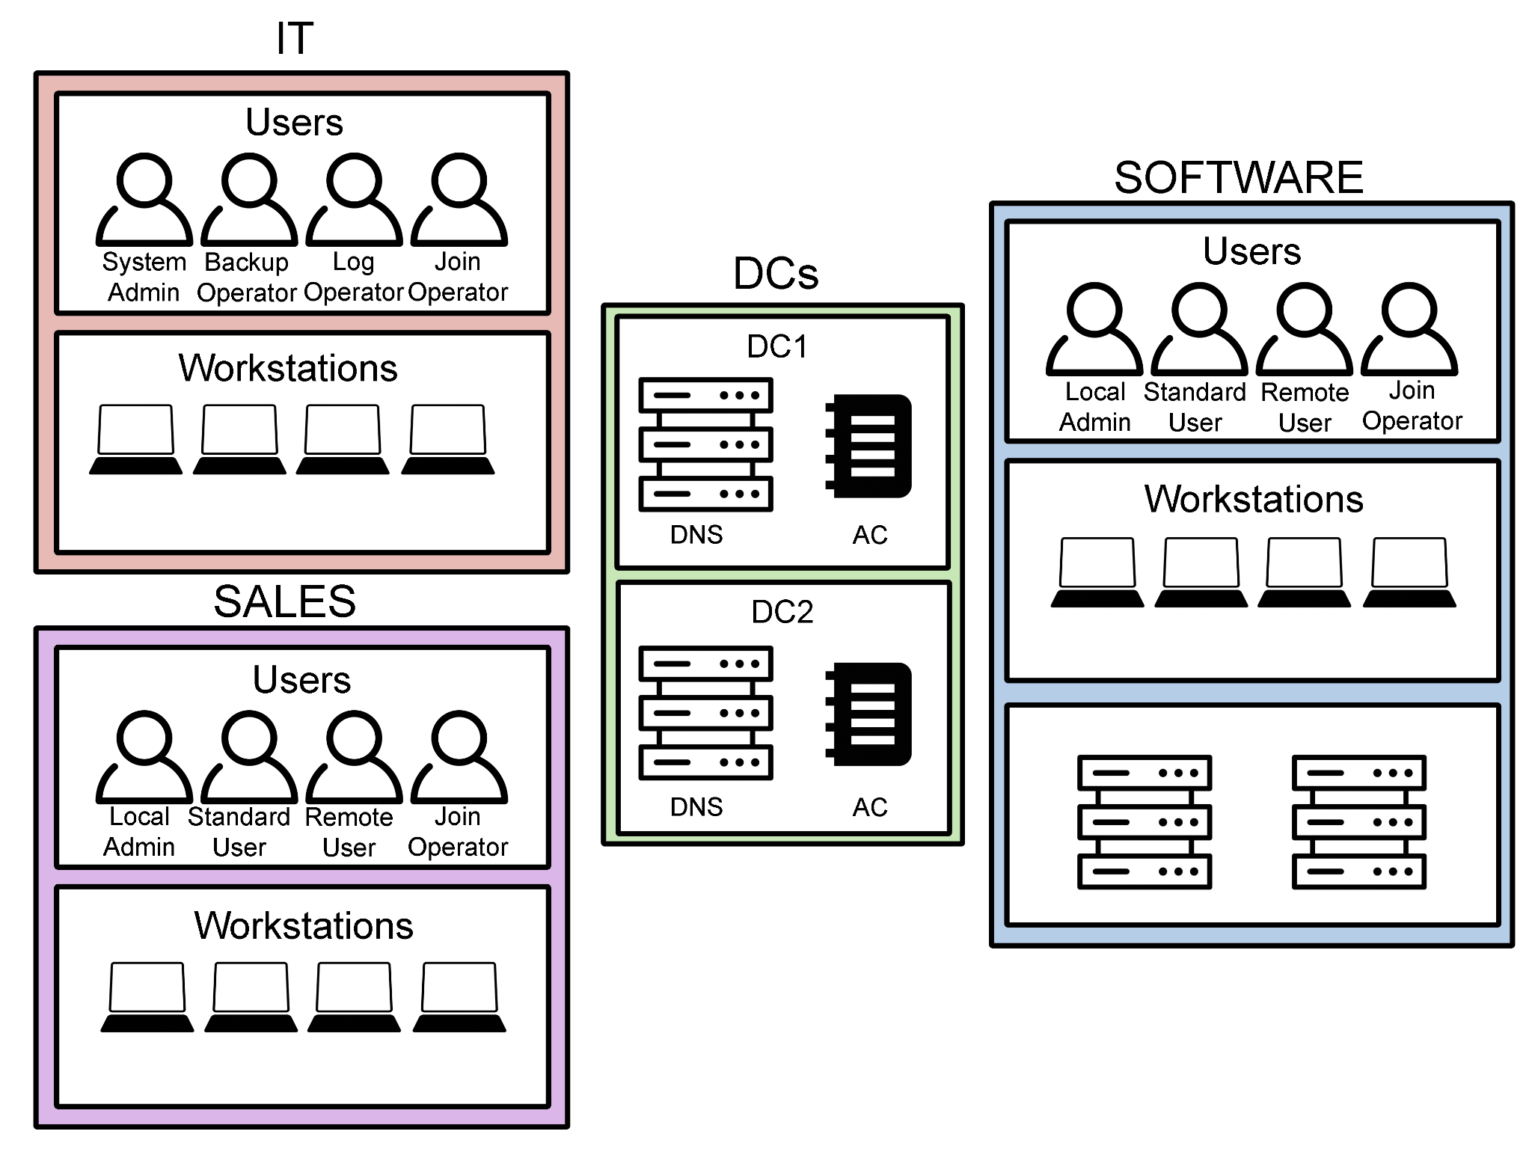

## **User Accounts and Group Policies**

* IT OU
  + System Administrator

▪ + User accounts

▪ + Manage system updates

▪ + Manage applications

▪ + Remote access to domain controllers

* Backup Operator
* Log Operator
* Join Operator

▪ + workstations

* Software OU
  + Local Administrator

▪ + User accounts

▪ + Manage system updates

▪ + Manage applications

* + - Member of local administrators
  + Join Operator

▪ + workstations

* + Standard User
    - - Remote access
    - - install apps
    - - install updates
    - - add users

▪ + scheduled access time

* + Remote User

▪ + Remote access

* Sales OU
  + Local Administrator

▪ + User accounts

▪ + Manage system updates

▪ + Manage applications

* + - Member of local administrators
  + Join Operator

▪ + workstations

* + Standard User
    - - Remote access
    - - install apps
    - - install updates
    - - add users

▪ + scheduled access time

* + Remote User

▪ + Remote access

## **IT OU Group**

* Consists: System Administrator, Backup Operator, Log Operator, Join Operator

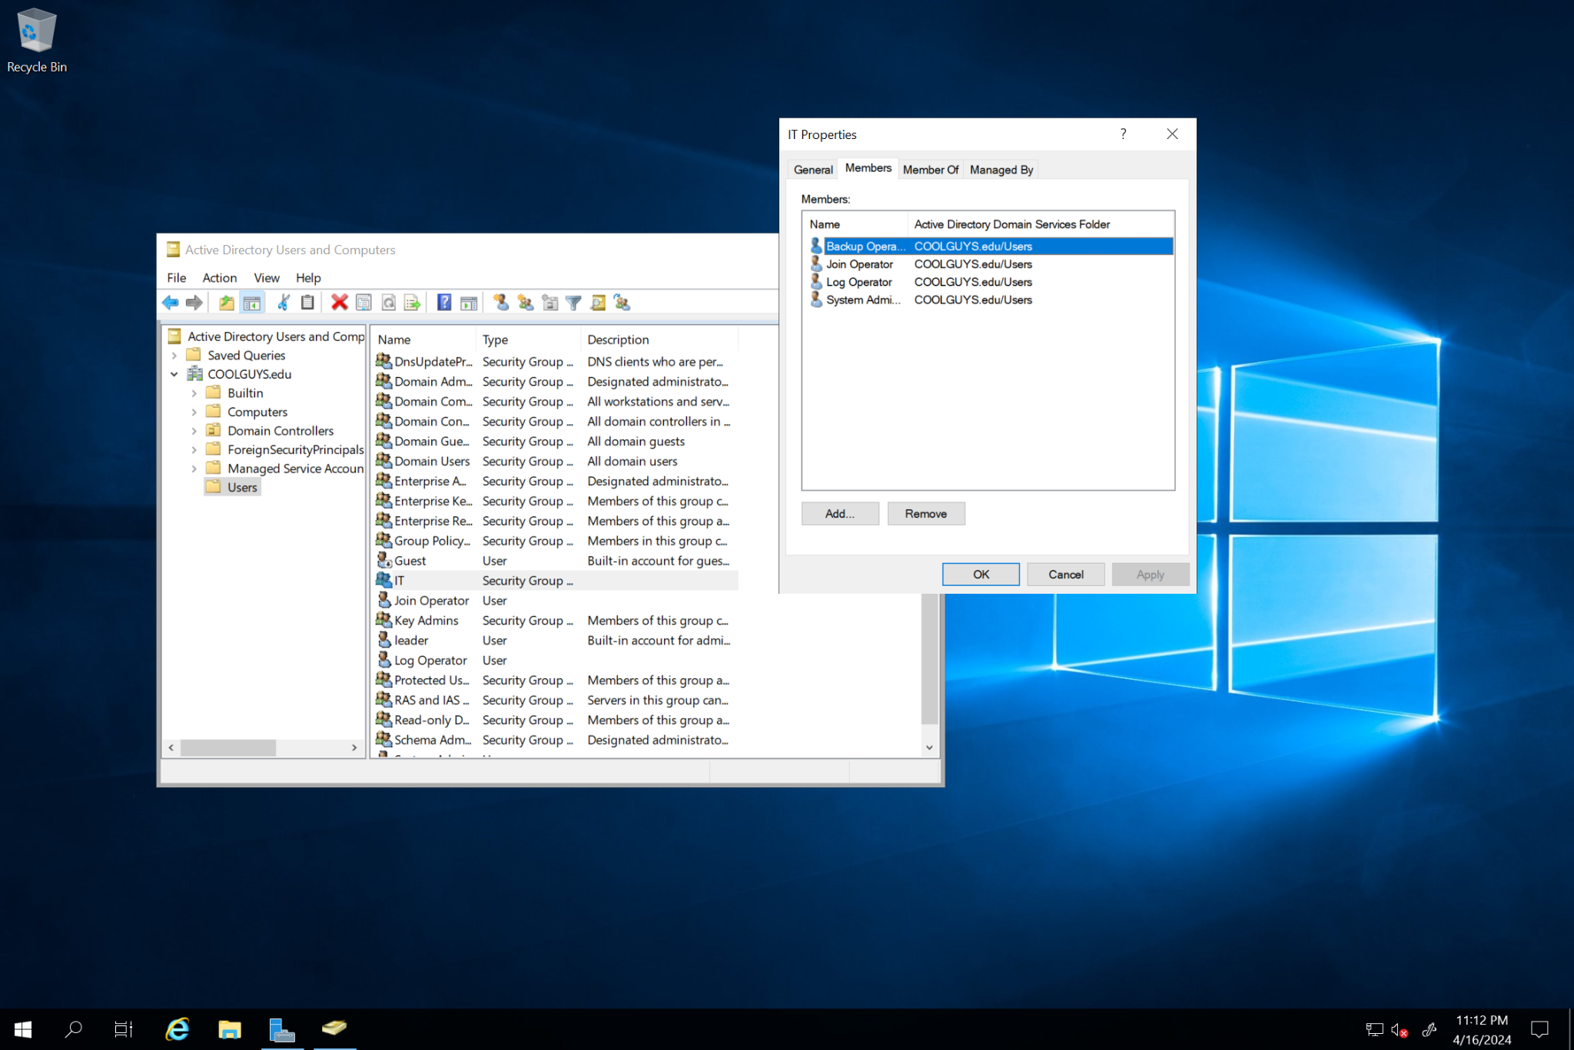

## Software OU Group

* Consists: Local Administrator, Join Operator, Standard User, Remote user

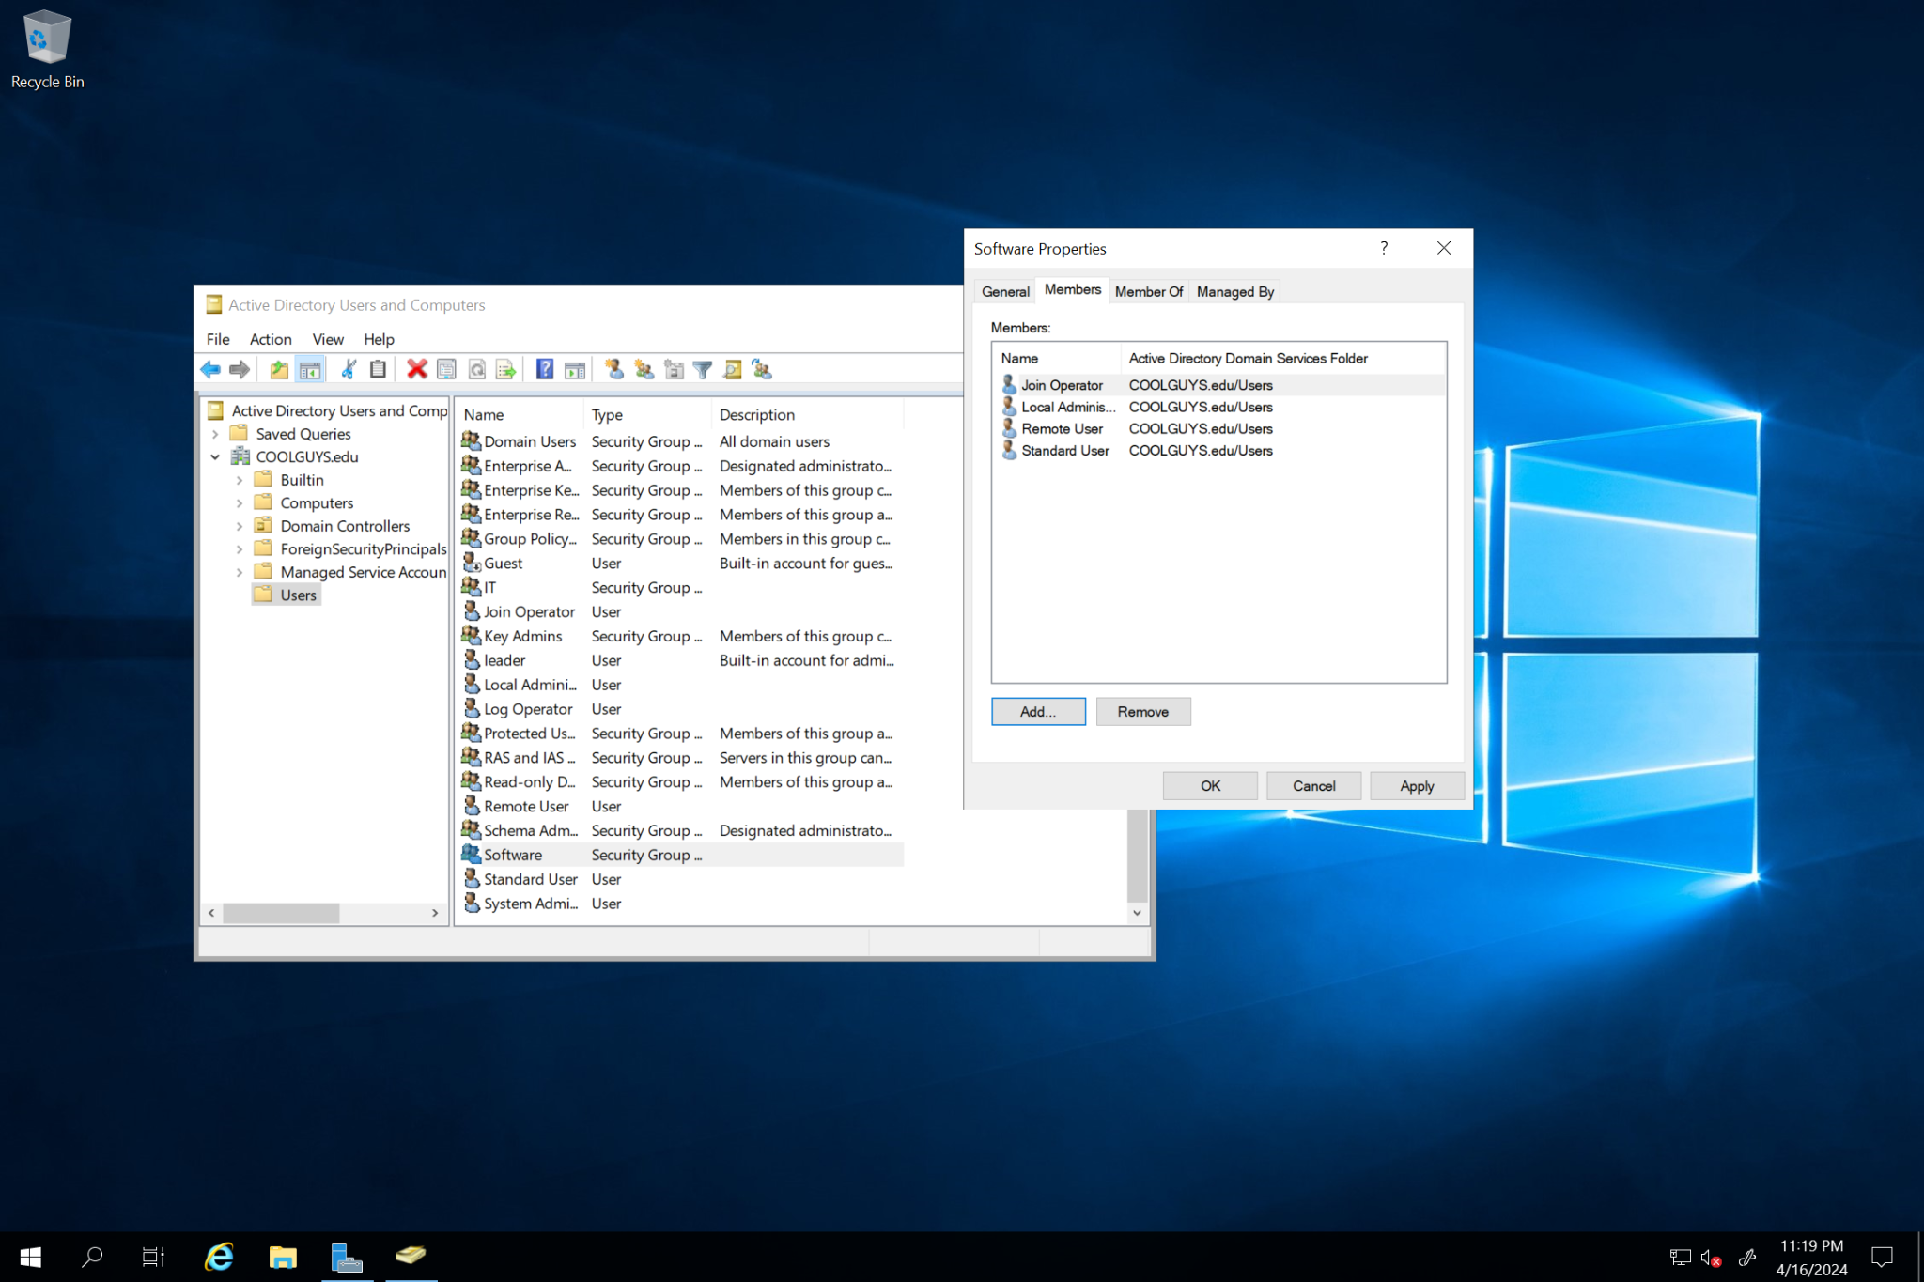

## Sales OU Group

* Consists: Local Administrator, Join Operator, Standard User, Remote User

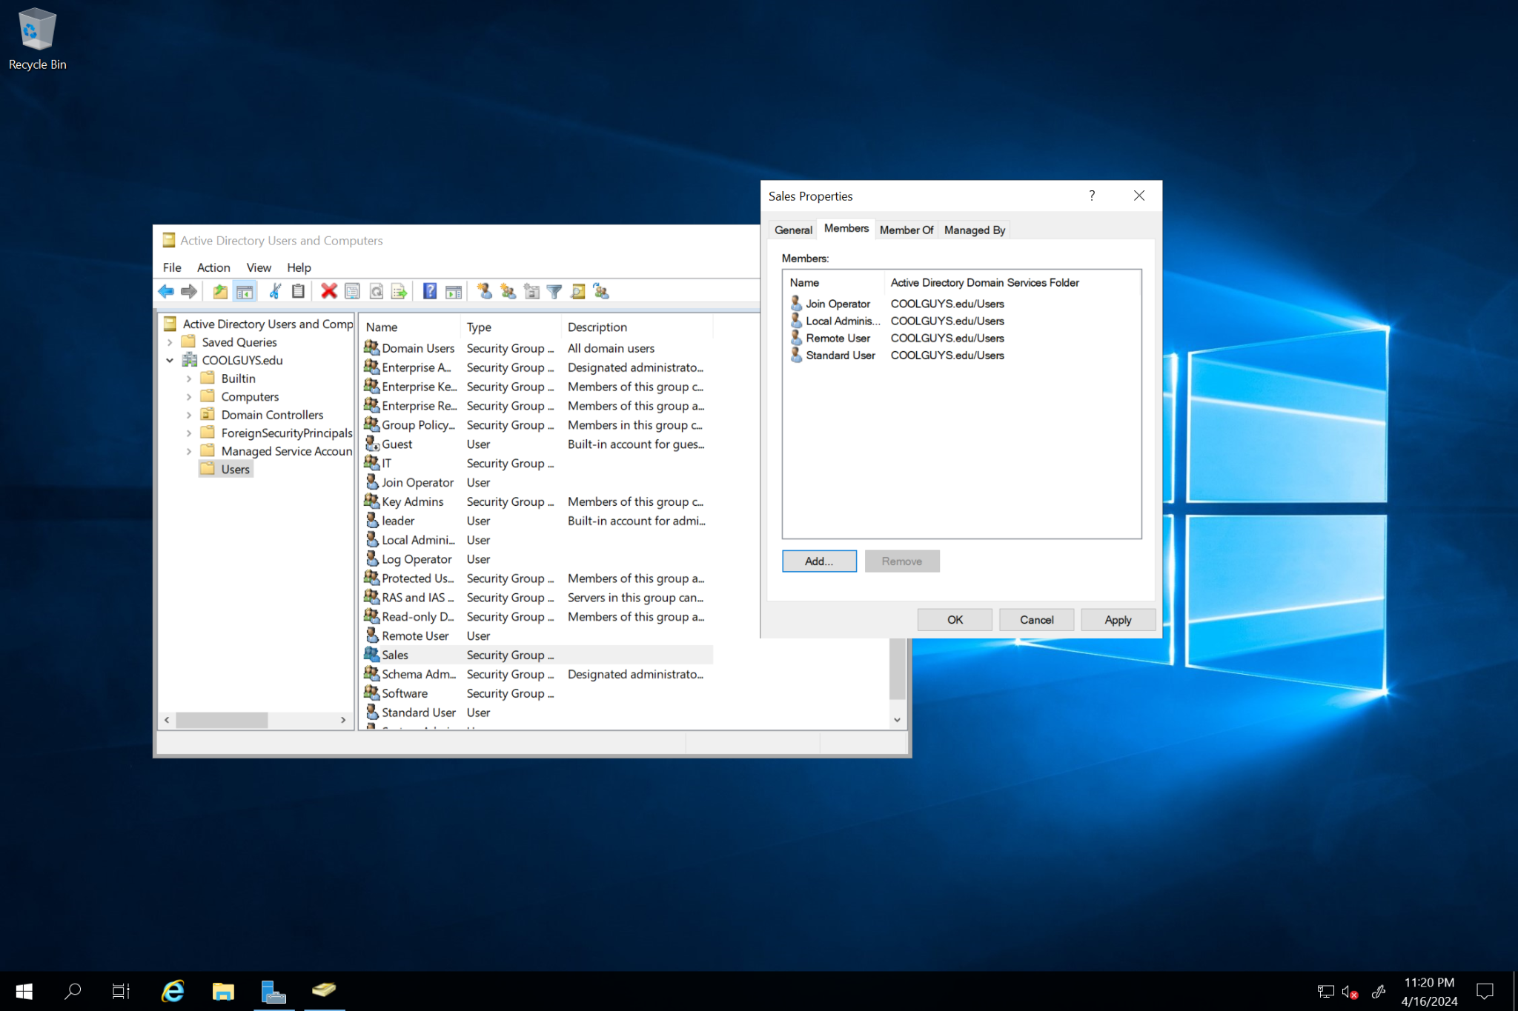

## Group Policy

### Sales OU GPO

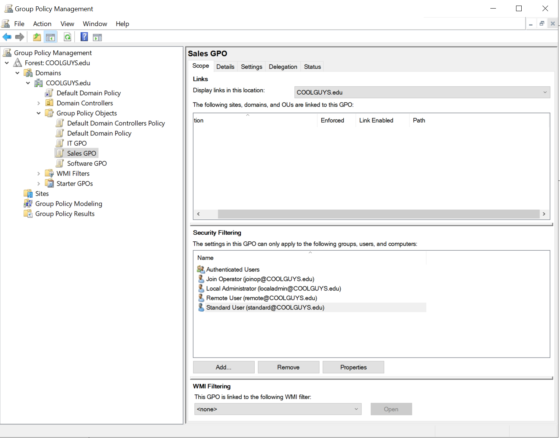

### Software OU GPO

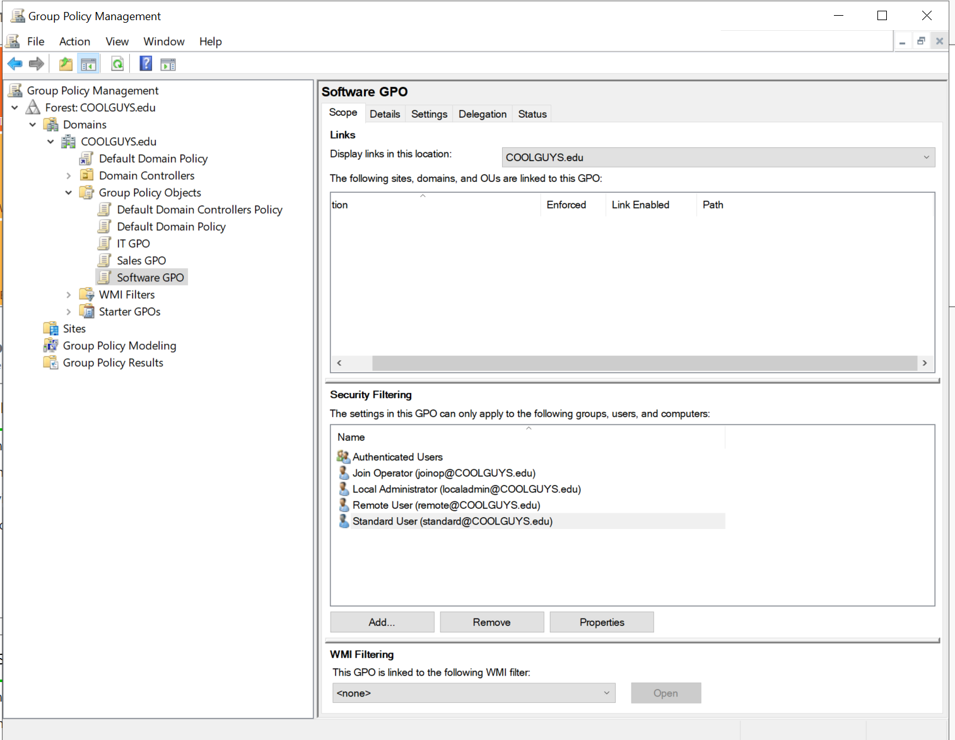

### IT OU GPO

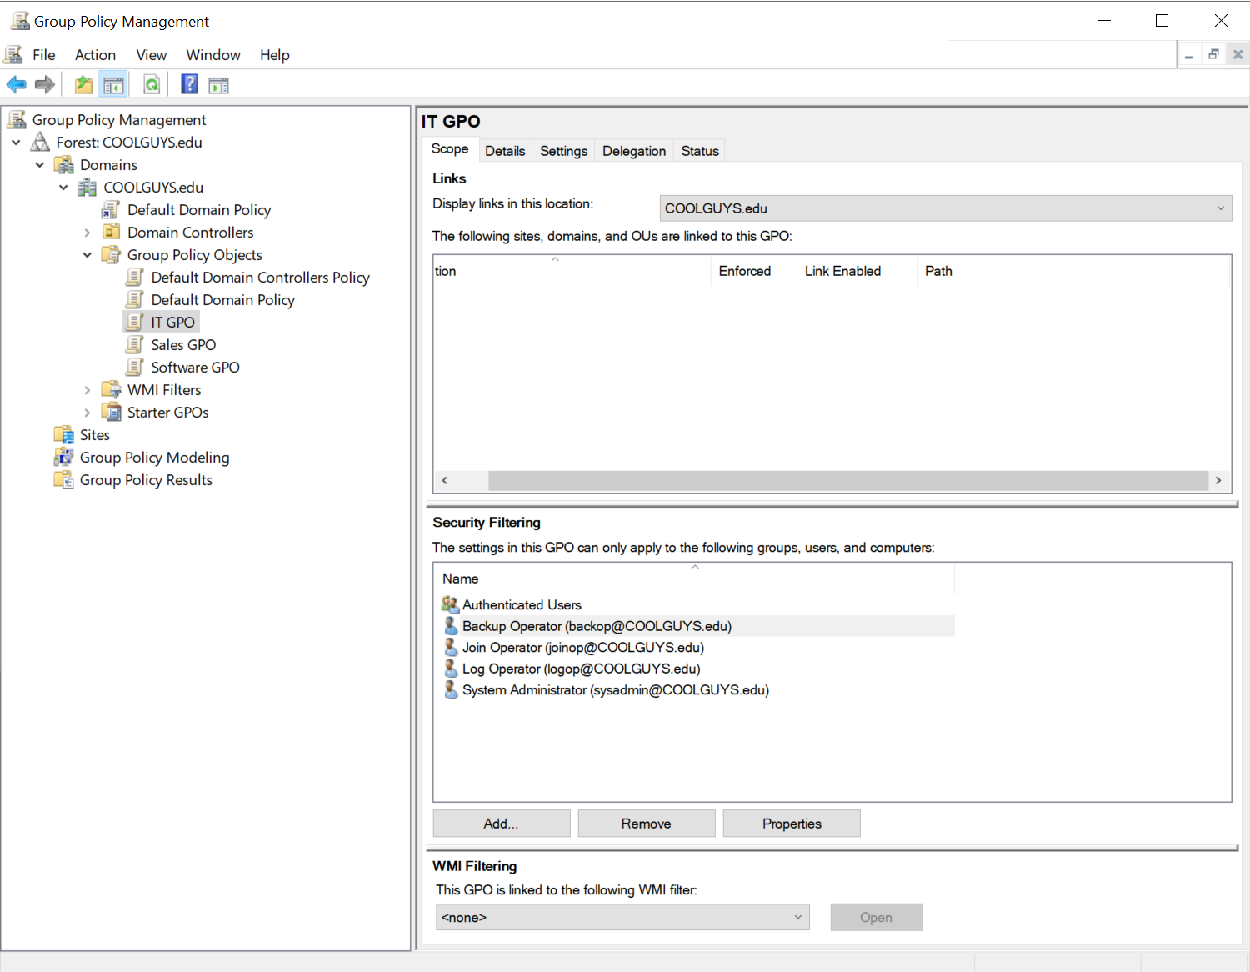

### Allowing Remote User RDP Access

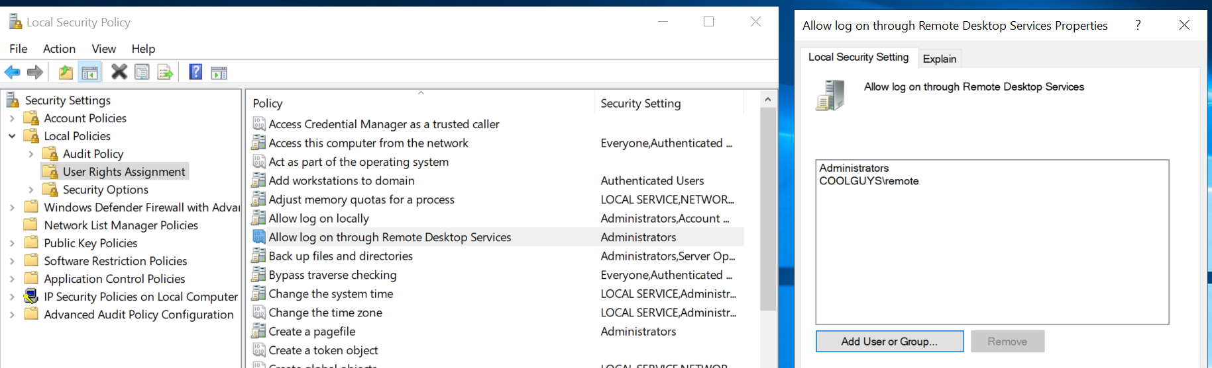

### Password Policy

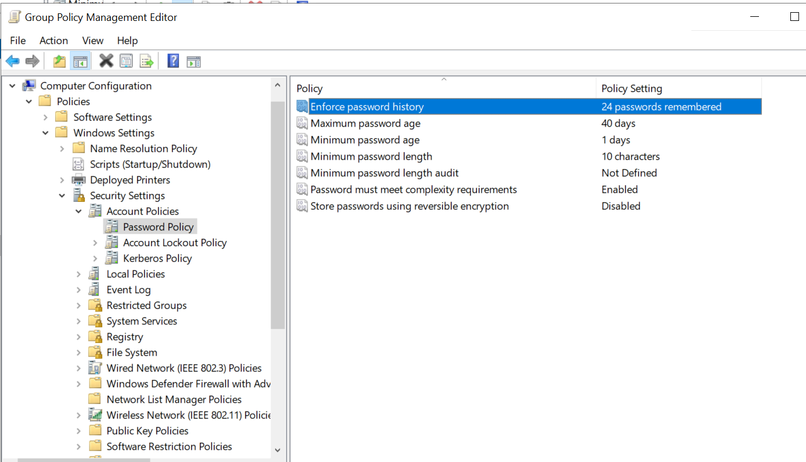

### Restricting Logon Time for Standard User

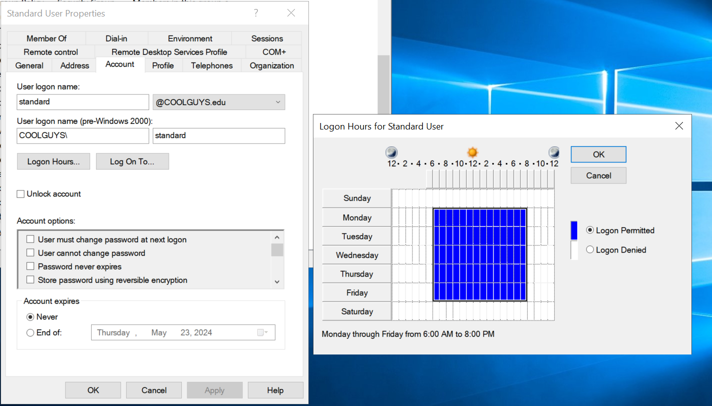

### Adding a Logon Message for Users Accessing Organization Workstations

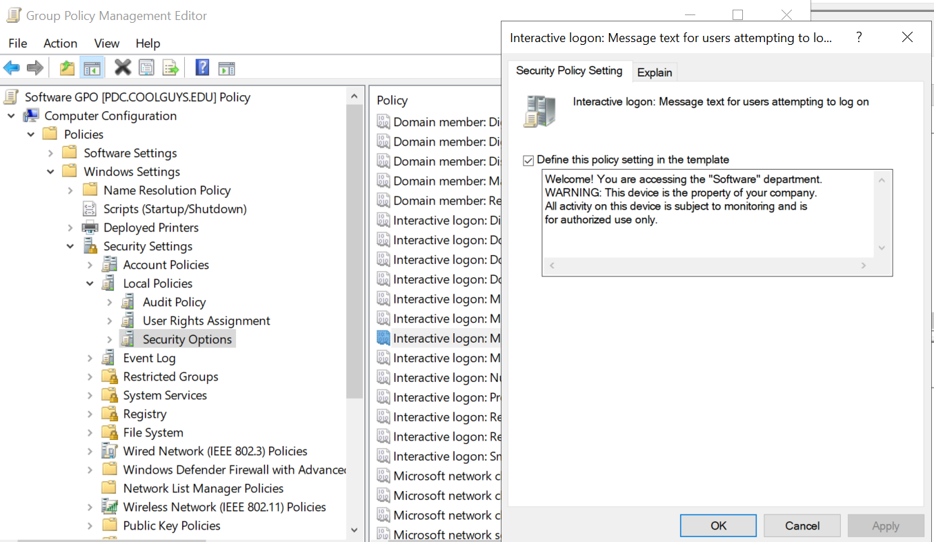

## Explanation of Adding Future Departments

With the way our group designed the network and website, it is possible for the company to continue its growth. The network is designed with sufficient IP addresses that can support all current users plus room for growth, specifically, up to 1024 hosts with a /22 subnet (see Network Topology Diagram). The main growth our group anticipated was the addition of future departments to the company. Future departments can be added by first adding an additional departmental website. This additional website would likely be private but able to communicate with the other department websites (currently sales and software). The next steps regarding the addition of future departments involve the active directory (AD). In the AD, a new group policy object (GPO) would have to be made for the new department, with proper user and policy setup. Once the GPO has been properly created, users would be added to the department’s GPO under the proper user role (depending on their position). All of these steps would have to be done by a user with sufficient permissions, likely an IT administrator user.

## Organization Website

* Link: <https://alecankrum47.wixsite.com/sample-business>
* Sales Password: password123
* Software Password: password321
* Main Page



* Password Protected Page

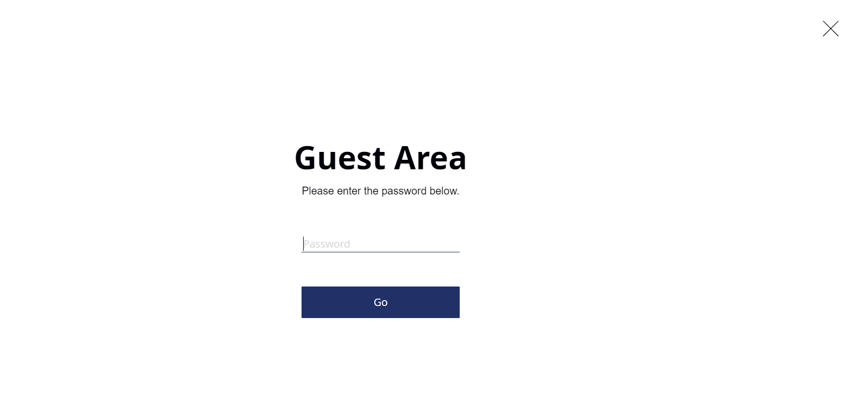

* Sales Page

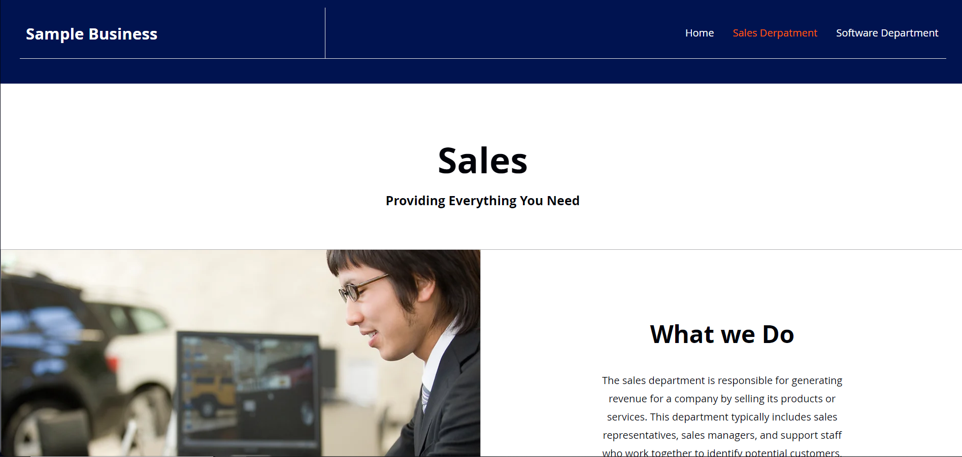

* Software Page

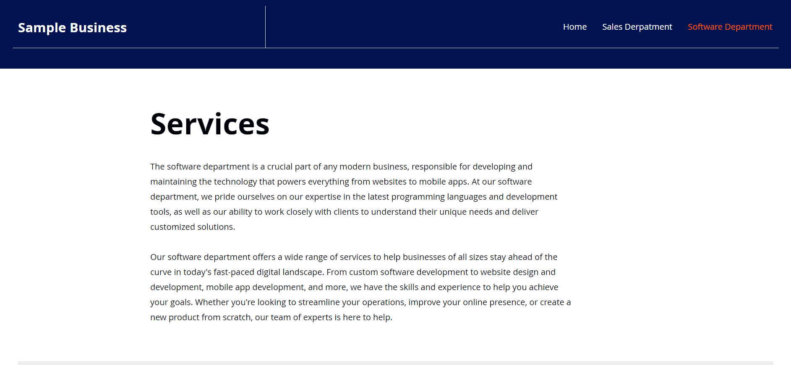

* Department Example Public Facing



## Linux Server Documentation

Setting up the software department users on the Linux development server

### Commands to Create “Software” Group and Add Users to Software Group

sudo groupadd software

sudo adduser localadmin

sudo adduser joinoperator

sudo adduser standarduser

sudo adduser remoteuser

sudo usermod -a -G software localadmin

sudo usermod -g software localadmin

sudo usermod -a -G software joinoperator

sudo usermod -g software joinoperator

sudo usermod -a -G software standarduser

sudo usermod -g software standarduser

sudo usermod -a -G software remoteuser

sudo usermod -g software remoteuser

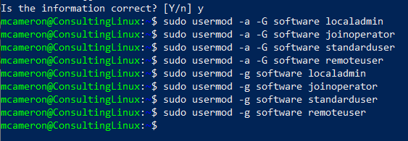

### cat /etc/passwd

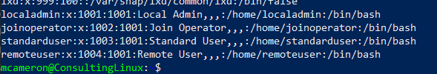

### cat /etc/group

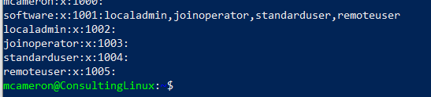

### Allow ”remoteuser“ to SSH remotely

sudo vi /etc/ssh/sshd_config

Add last 2 line, “PasswordAuthentication yes” “AllowUsers remoteuser”

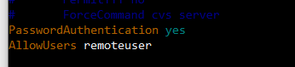

### Restrict “standarduser’s” access time from 6:00AM to 10:00PM Monday – Friday

sudo vi /etc/security/time.conf



### Allow “localadmin” sudo privileges to add users and manage applications

sudo visudo

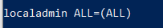

## Configuring the Organizational Firewall Server using UFW

### sudo ufw enable



### Allow all Incoming Http and Https Traffic

sudo ufw allow http

sudo ufw allow https

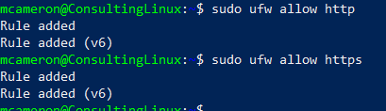

### Allow the Organizational System Administrator to Remotely Access the Firewall Server

sudo ufw allow from 10.11.13.7 to any port 22

sudo ufw status

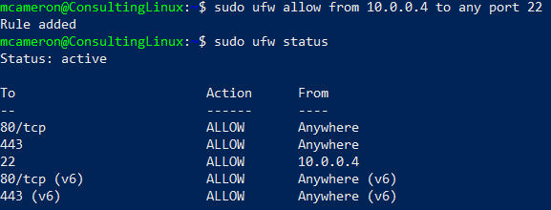

## 

## Team Members and Participation Notes

Alec Ankrum - Website creation and setup, adding future departments, PPT presentation

Annabel Fuina - Primary and secondary DC, Group Policies, Network Topology, PPT presentation

Mordred Cameron - Business Logic, Software department Linux user server setup, Firewall setup, PPT presentation

# Conclusion

In conclusion, we deepened our understanding of designing a solution for a company that addresses business logic/diagram, networks, servers, firewalls, website creation, system configuration, and future expansion based on the company’s business rules we received. By the end of the project we created an active directory, with two domain controllers, that has proper group policies and user specifications based on the company’s request. This active directory setup included an explanation of future expandability regarding additional departments needing to be added. We also created a website with private departmental websites that communicate as well as a public facing website. Furthermore, we made a Linux server for the software department’s development space and another Linux server for a network firewall. All of these various tasks for the company helped show our team how communication and collaboration is needed to accomplish the requirements for a real world consulting project. Outside assistance was used for creating a group Azure resource (Rolyon, 2024).

# References

*How to set logon hours in Active Directory*? (n.d.). ManageEngine ADAudit Plus. https://www.manageengine.com/products/active-directory-audit/kb/how-to/how-to-set-logon-hours-in-active-directory.html

McNamara, P. (2023, May 22). *How To Implement a Secure Group Policy*. MentorCruise. https://mentorcruise.com/blog/how-to-implement-a-secure-group-policy-4d8ff/

Rolyon. (2024, February 28). *Assign Azure roles to external users using the Azure portal - Azure RBAC*.https://learn.microsoft.com/en-us/azure/role-based-access-control/role-assignments-external-users